**Overload the** polygon() **method that we coded in class so that the method can be used in a variety of ways. Here are the method headings for the 7 versions of** polygon() **with a description of their parameters:**

polygon() – draws a pentagon in the middle of the screen that has a radius of 100 pixels

polygon(float x, float y) – draws a pentagon at the (x,y) coordinate given with a radius of 100 pixels

polygon(float x, float y, int numSides) – a numSides-sided polygon at the (x,y) coordinate given with a radius of 100 pixels

polygon(float x, float y, int numSides, float sz) – a ?-sided polygon at the (x,y) coordinate given with a radius of sz pixels

polygon(float x, float y, int numSides, float sz, float rotation) – a ?-sided polygon at the (x,y) coordinate given with a radius of sz pixels that is rotated by a given amount

polygon(float x, float y, int numSides ,float sz, float rotation, float sWeight) – a ?-sided polygon at the (x,y) coordinate given with a radius of sz pixels that is rotated by a given amount with a certain thickness on the borders

polygon(float x, float y, int numSides, float sz, float rotation, float sWeight, color strokeColor, color fillColor) – a ?-sided polygon at the (x,y) coordinate given with a radius of sz pixels that is rotated by a given amount with a certain thickness on the borders and a specific color for the border and the interior

**Put the following 7 method calls into the** draw() **method to make sure your methods work.**

polygon();  
polygon(600, 200);  
polygon(150, 300, 7);  
polygon(700, 500, 6, 40);  
polygon(250, 100, 8, 40, PI/8);  
polygon(150, 500, 4, 70, PI/4, 10);  
polygon(500, 450, 10, 150, 0, 5, color(180), color(0, 0, 100));

**Your picture should look like this:**

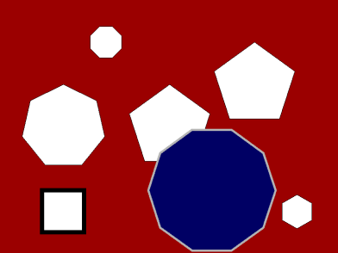

**Bonus** – Write an 8th polygon() method that allows you to change how the lines connect together (you will be using a method that you have never seen before- look in the reference)